**RIYA INDAP,44**

Code for BCD packed to unpacked conversion:

model small

stack 10h

data segment

num db 95h

num1 db ?

num2 db ?

data ends

code segment

assume cs:code,ds:data

start:

mov ax,data

mov ds,ax

mov ah,00h

mov al,num

and al,0fh

mov num1,al

mov al,num

and al,0f0h

mov cl,04h

shr al,cl

mov num2,al

mov ah,4ch

int 21h

code ends

end start

**output:**

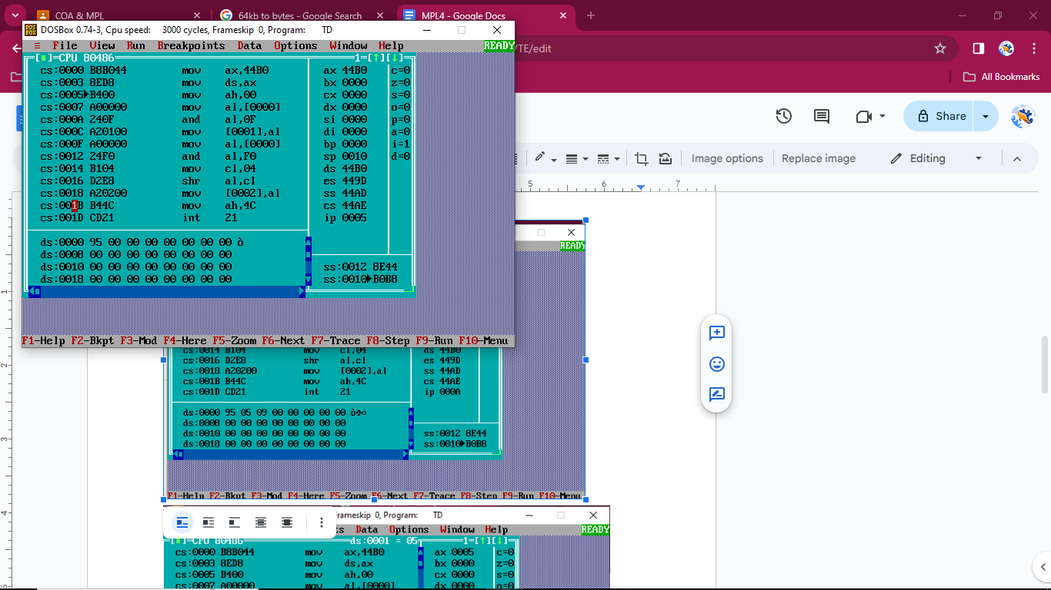

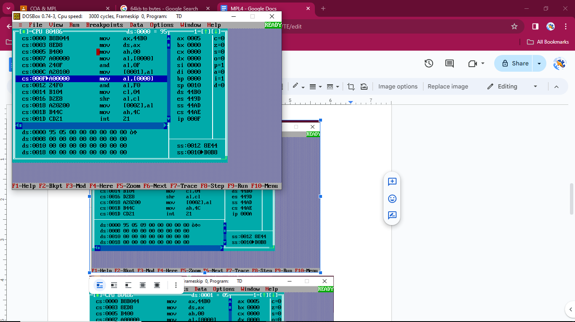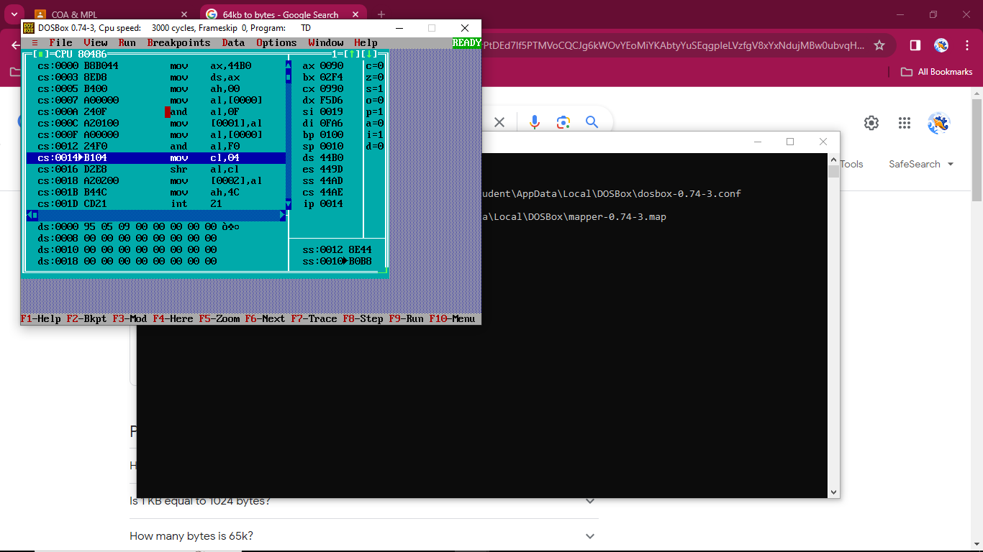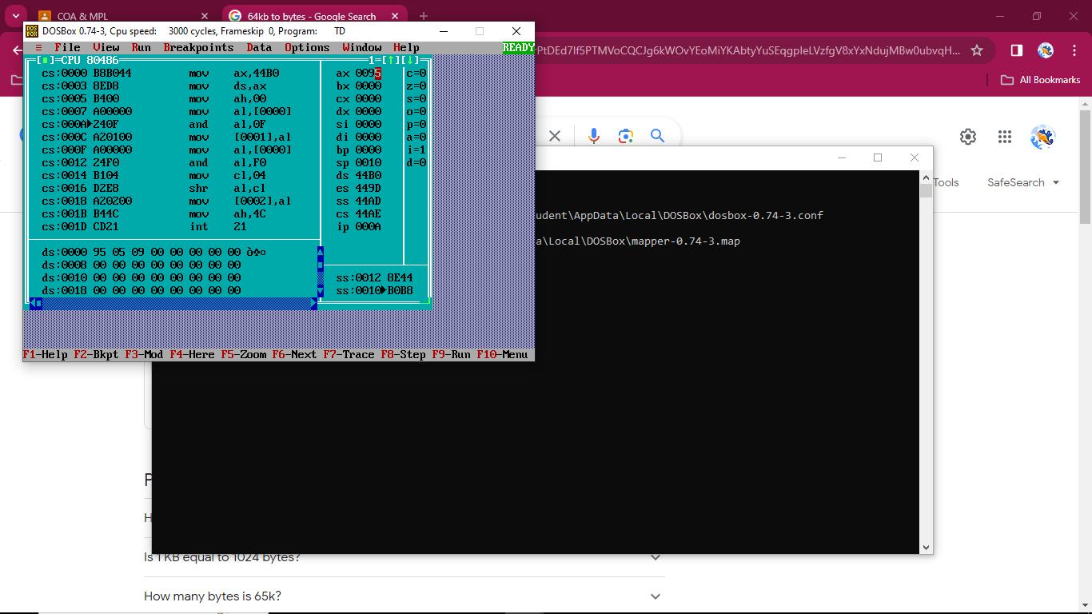

Code for 16-bit BCD addition:

model small

Stack 10h

data segment

num1 dw 1234h

num2 dw 5678h

res dw 00h

data ends

code segment

assume cs:code, ds:data

start:

mov ax,data

mov ds,ax

mov ax,num1

mov bx,num2

add ax,bx

mov ax,num1

mov bx,num2

add al,bl

daa

mov cl,al

adc ah,bh

mov al,ah

daa

mov ch,al

mov res,cx

mov ah,4ch

int 21h

code ends

end start

